Dear PWCS Family,

The Virginia Department of Education (VDOE) has created the Virginia Assessment Program to help measure students’ academic progress in the Standards of Learning (SOLs). The SOLs indicate the Commonwealth of Virginia’s expectations for what students should know and be able to do in the subject areas of reading, writing, mathematics, science, and history/social science. Copies of the SOLs are available online at the VDOE website at <http://www.doe.virginia.gov>.

Each year, students at various grade levels are expected to participate in SOL testing or alternative assessments unless specifically exempted by state or federal law, or by Virginia Board of Education regulations. In grades 3-8, most students will participate in some type of SOL testing or assessment annually. High school students typically participate when they need a qualifying score to earn verified credit toward graduation or satisfy federal participation requirements. Some SOL tests, like Algebra I, are only given at the completion of the courses. Some SOL tests, like the Integrated Reading and Writing test, are only given to students in grades 5 and 8. According to VDOE, parents may also request to have their high school student participate in additional testing beyond what is required by state and federal law if they are currently enrolled in a related course.

Once testing is complete, information about your student’s performance will be shared with you. For more information about general testing windows in PWCS, please visit our website at:

<https://www.pwcs.edu/departments/accountability/testing/testing_calendar>

For more specific information about actual test dates for your student or the tests in which they will participate, please contact your student’s school directly.

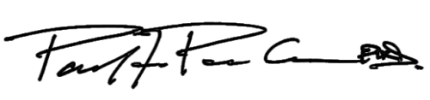Sincerest regards,

Paul F. Parker, Ph.D.

Supervisor of Testing